A)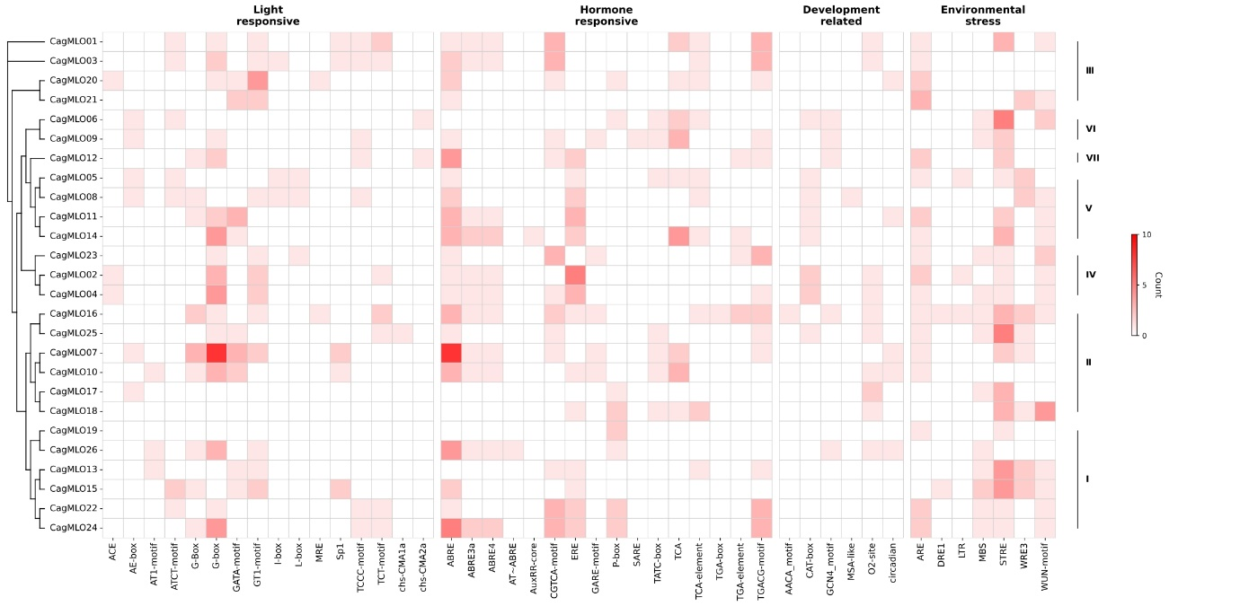

B)
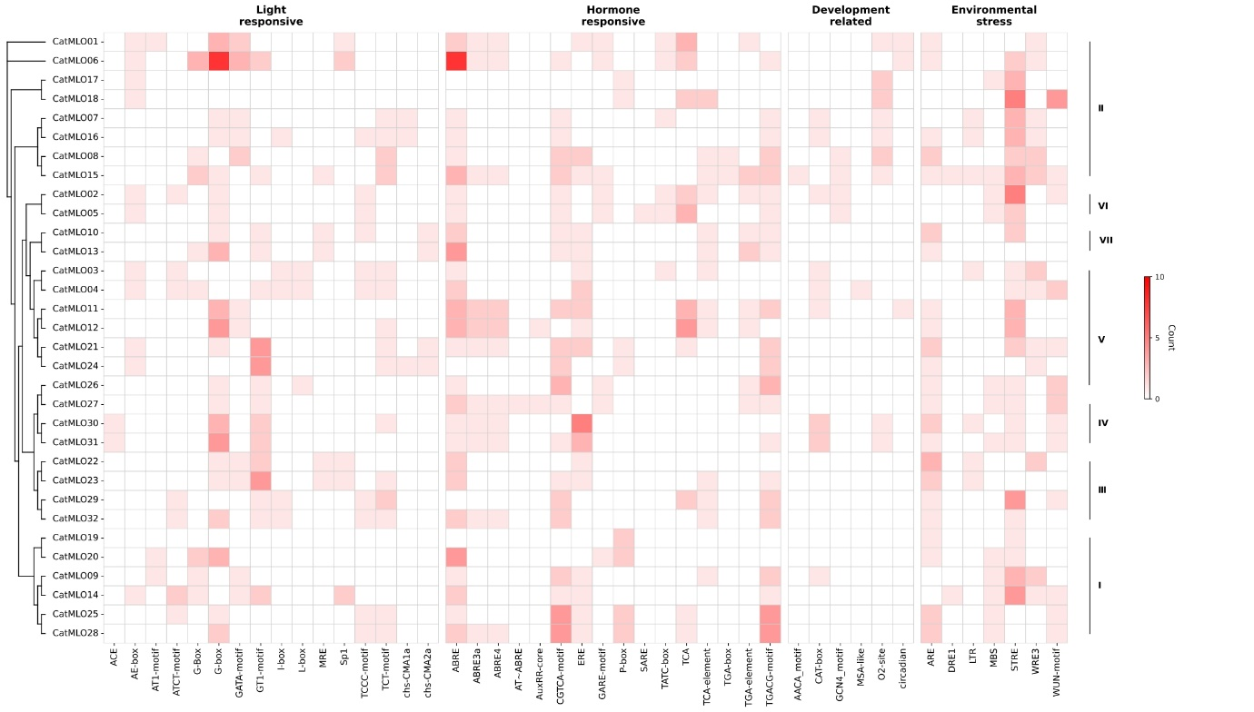
Supplementary Fig. S6. Cis-acting regulatory element profiles of MLO gene promoters in Coffea genomes.

C)
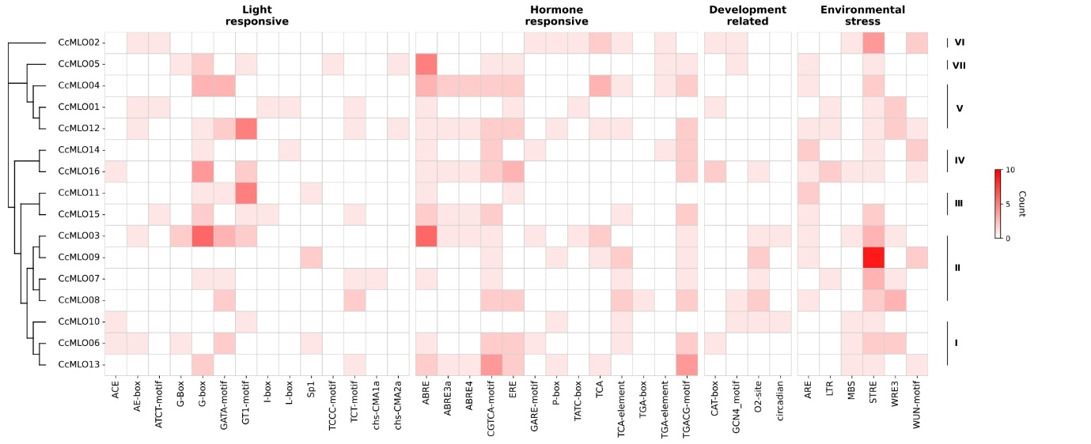
D)
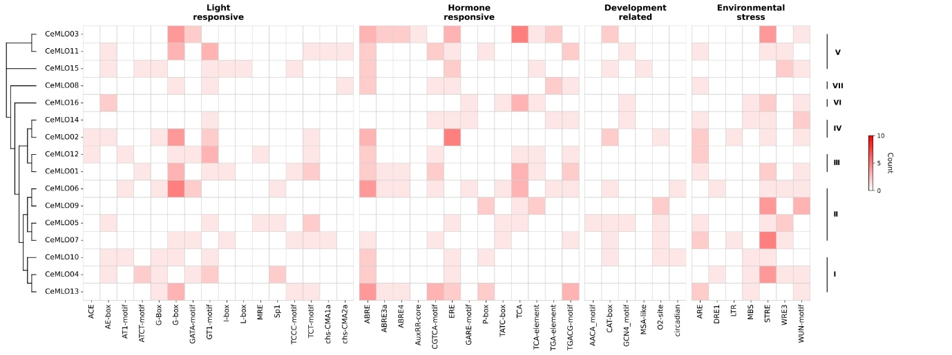
Supplementary Fig. S6. Cis-acting regulatory element profiles of MLO gene promoters in Coffea genomes. Analyses include (A) C. arabica cv. Geisha, (B) C. arabica cv. Typica, (C) C. canephora, and (D) C. eugenioides. Promoter regions (1,500 bp upstream of ATG) were analyzed. Phylogenetic relationships are shown on the left, and the distribution of cis-regulatory elements (CREs) is presented as a heatmap (white, low; red, high). Elements are grouped by functional category at the top, with individual element names shown at the bottom. Major clades are indicated on the right.

