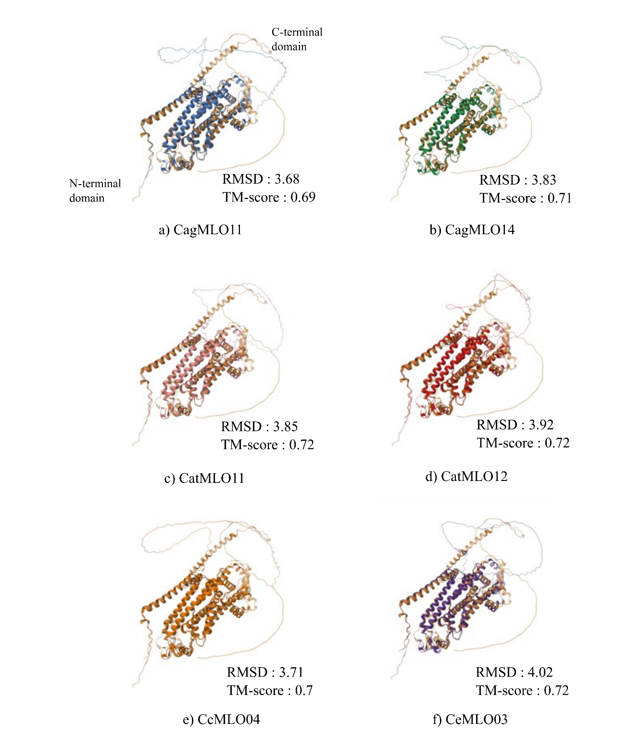
Supplementary Fig. S5. Structural superposition of AtMLO11 and Clade V–ii coffee MLO proteins.
Predicted structures of six Clade V–ii coffee MLO proteins were aligned with Arabidopsis AtMLO11. The reference structure is shown in colored tan. RMSD and TM-score values are provided for each comparison. N- and C-terminal orientations are shown in the first panel only.

