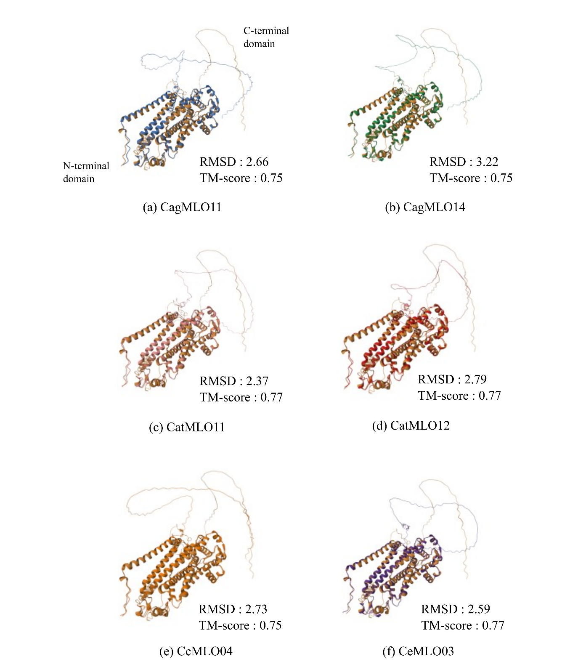
Supplementary Fig. S4. Structural superposition of AtMLO02 and Clade V–ii coffee MLO proteins.
Predicted 3D structures of six Clade V–ii coffee MLO proteins were individually aligned with Arabidopsis AtMLO02. The reference structure (AtMLO02) is shown in colored tan. Root mean square deviation (RMSD) and TM-score values are indicated for each comparison. N- and C-terminal orientations are shown in the first panel only.

