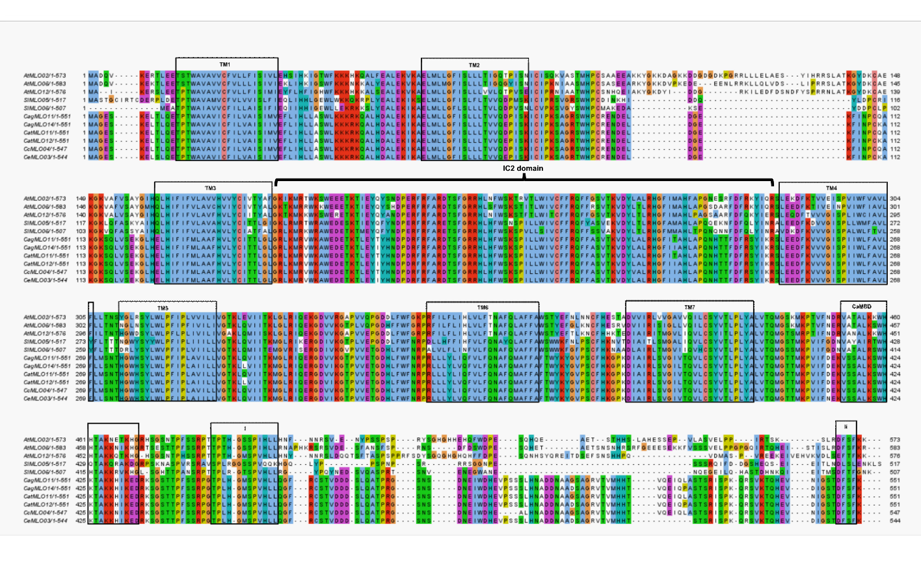
Supplementary Fig. S3. Sequence alignment of Clade V–ii coffee MLO proteins with known susceptibility factors. Multiple sequence alignment includes Clade V–ii coffee MLO proteins and characterized susceptibility powdery mildew susceptibility proteins from S. lycopersicum (SlMLO05, SlMLO06) and A. thaliana (AtMLO02, AtMLO06, AtMLO12). Black boxes indicate conserved features, including seven transmembrane domains (TM1–TM7), the calmodulin-binding domain (CaMBD), and peptide domains I and II in the C-terminal region. Black lines indicate the second intracellular loop (IC2).

