A)
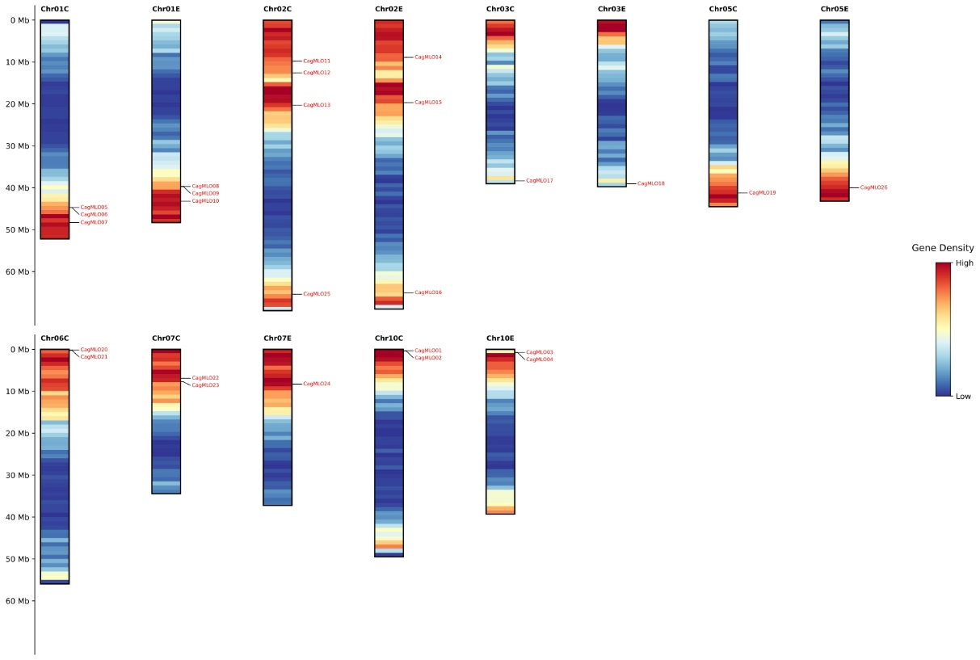

B)
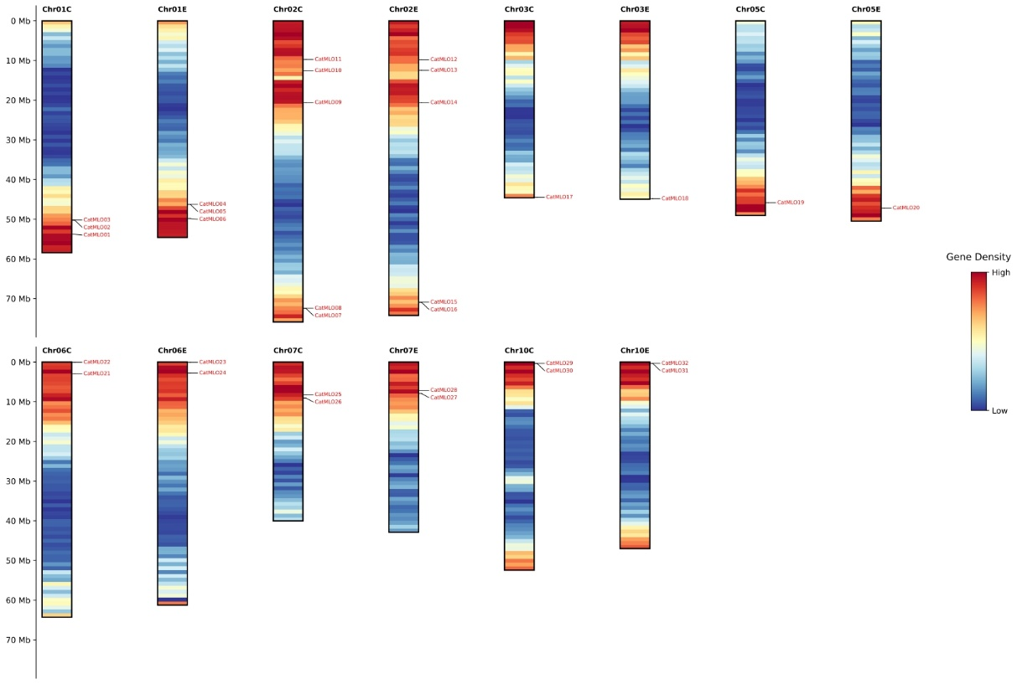
Supplementary Fig. S2. Chromosomal distribution and gene density of MLO genes in Coffea genomes.

C)
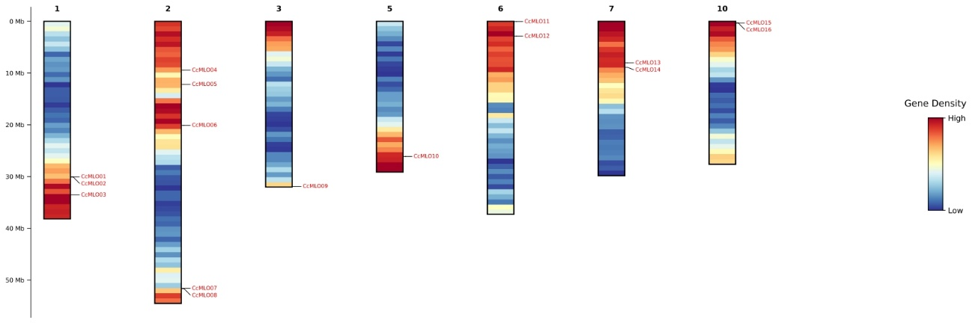

D)
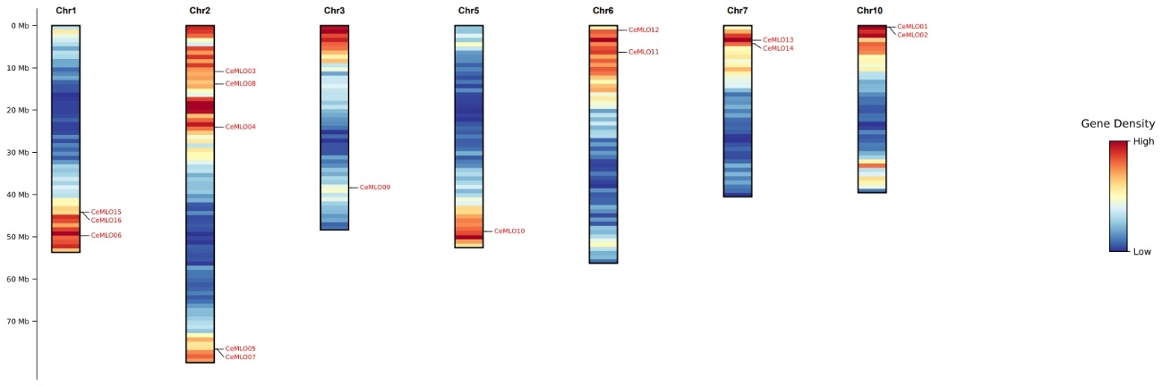

Supplementary Fig. S2. Chromosomal distribution and gene density of MLO genes in Coffea genomes.
Chromosomal locations of MLO genes are shown for (A) C. arabica cv. Geisha, (B) C. arabica cv. Typica, (C) C. canephora, and (D) C. eugenioides. Chromosome lengths (Mb) are indicated on the left axis, and gene density is visualized as a heatmap (blue, low; red, high). Only chromosomes containing MLO genes are displayed. In C. arabica, chromosome labels include ‘E’ and ‘C’ suffixes, denoting subgenome origins from C. eugenioides and C. canephora, respectively.

