A)
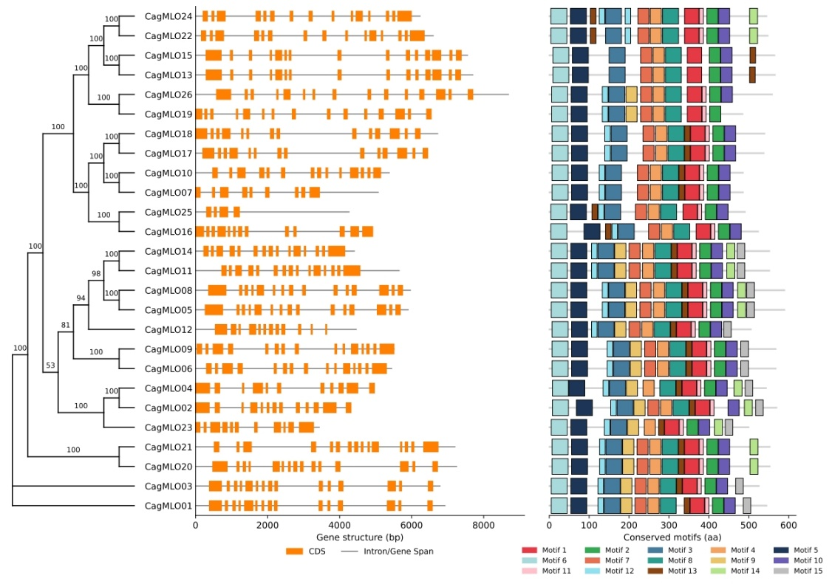
B)
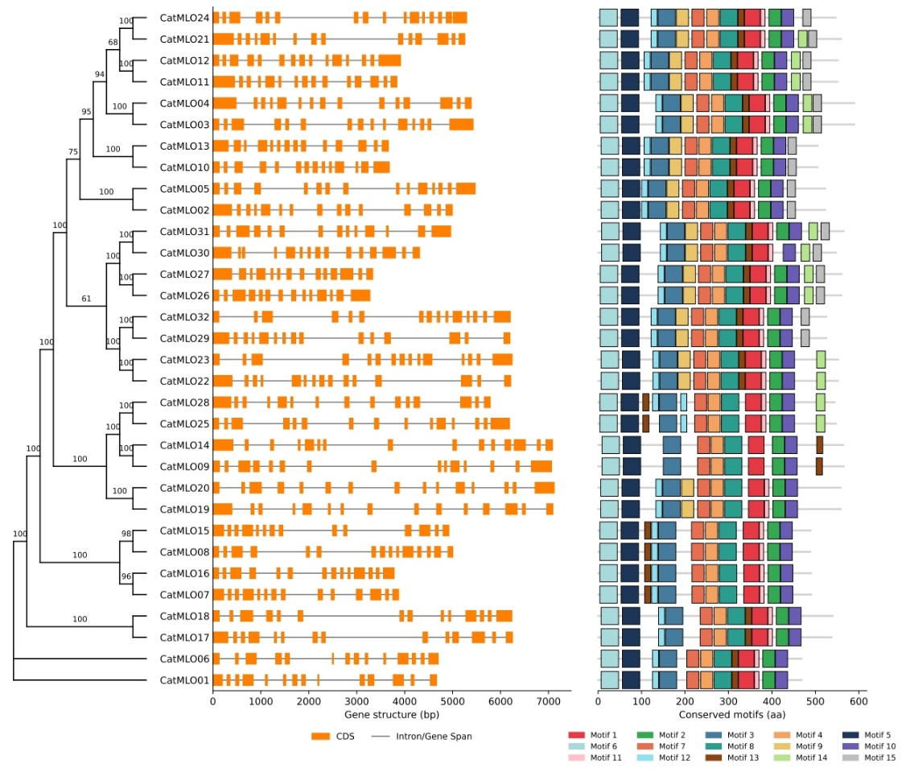
Supplementary Fig. S1. Phylogeny, gene structure, and conserved motifs of Coffea MLO genes.

C)
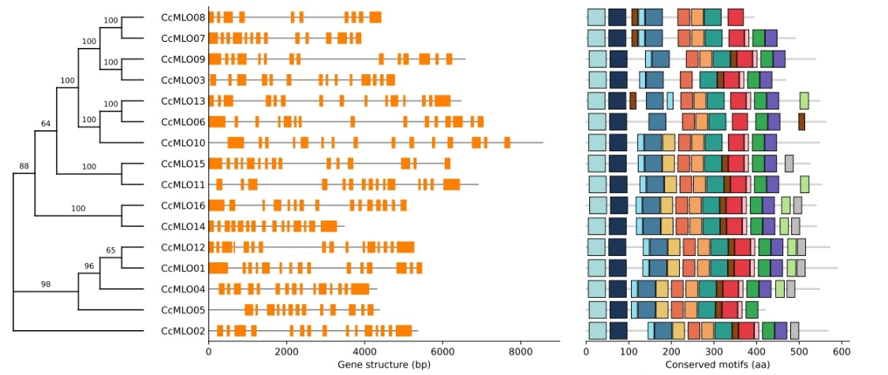

D)
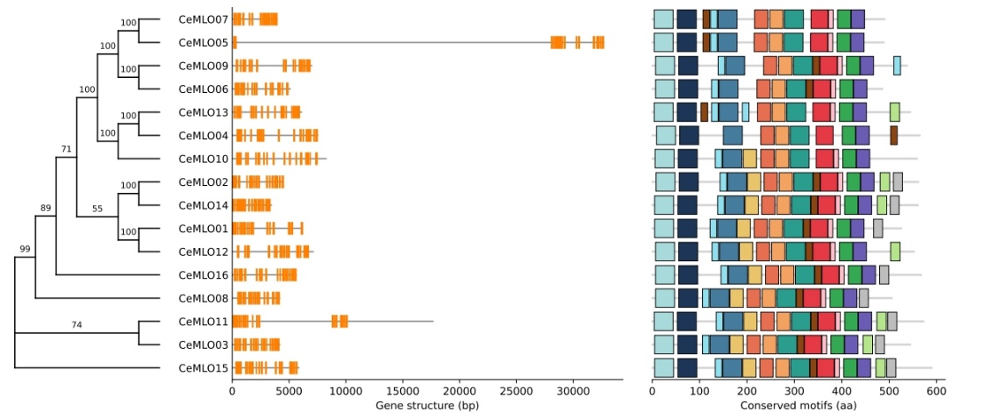
Supplementary Fig. S1. Phylogeny, gene structure, and conserved motifs of Coffea MLO genes.
Analyses are shown for (A) C. arabica cv. Geisha, (B) C. arabica cv. Typica, (C) C. canephora, and (D) C. eugenioides. Left panels show phylogenetic relationships, with Ultrafast Bootstrap (UFBoot) support values indicated at the nodes. Middle panels illustrate exon-intron structures, with coding sequences (CDS) shown as orange boxes and introns as connecting lines. Right panels display the distribution of 15 conserved protein motifs, each represented by a uniquely colored box.

