Supplementary Material

Manuscript No. HST-26-0629-02 — Comparative Characterization of Routine Quality Traits, Primary Metabolites, and TD-GC-MS-based Volatile Profiles in Three Newly Bred Peach (Prunus persica L.) Cultivars

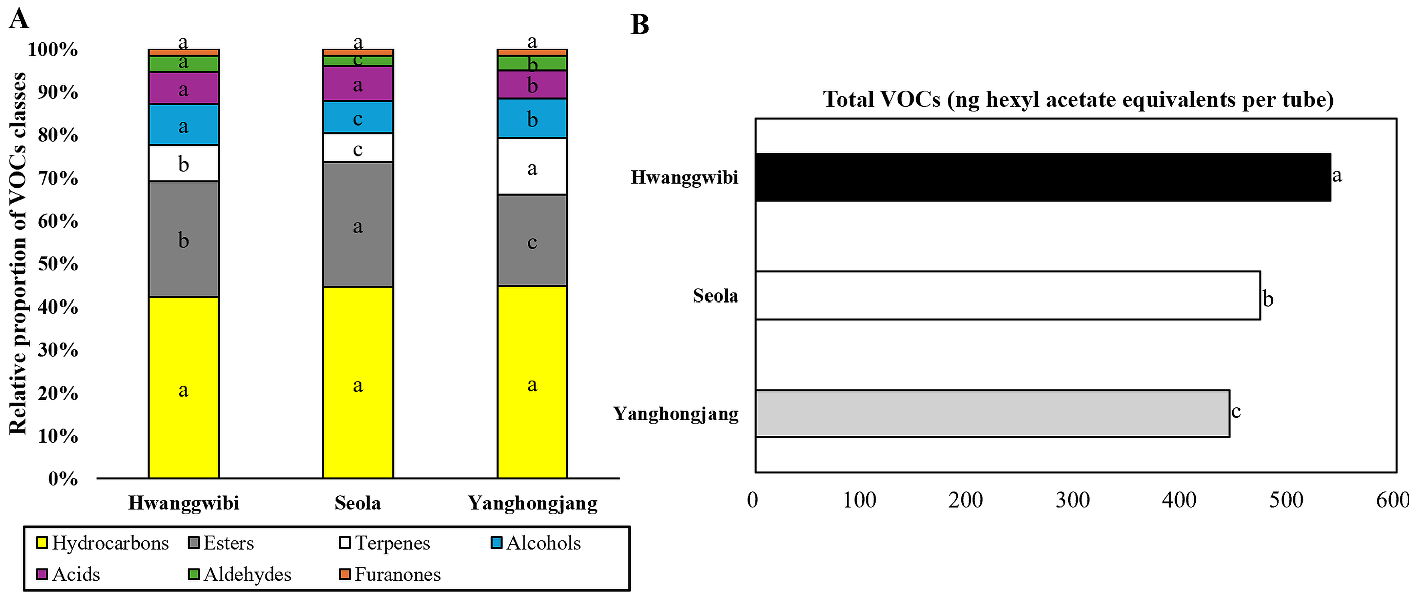
Supplementary Fig. S1. Comparison of volatile organic compound (VOC) class distributions and total VOC abundance levels among three peach cultivars: (A) Relative proportions of VOC classes, specifically hydrocarbons, esters, terpenes, alcohols, acids, aldehydes, and furanones, detected by TD-GC-MS. Values are expressed as percentages of the total VOC abundance within each cultivar. (B) Total VOC abundance expressed as ng hexyl acetate equivalents per tube. Values are presented as the mean ± SD (n = 4). Different letters indicate significant differences among the cultivars according to Tukey’s HSD test (P < 0.05).

