Supplementary Fig. S1. Schematic representation of the randomized complete block design (RCBD) used at both the Boeun and Goesan sites.
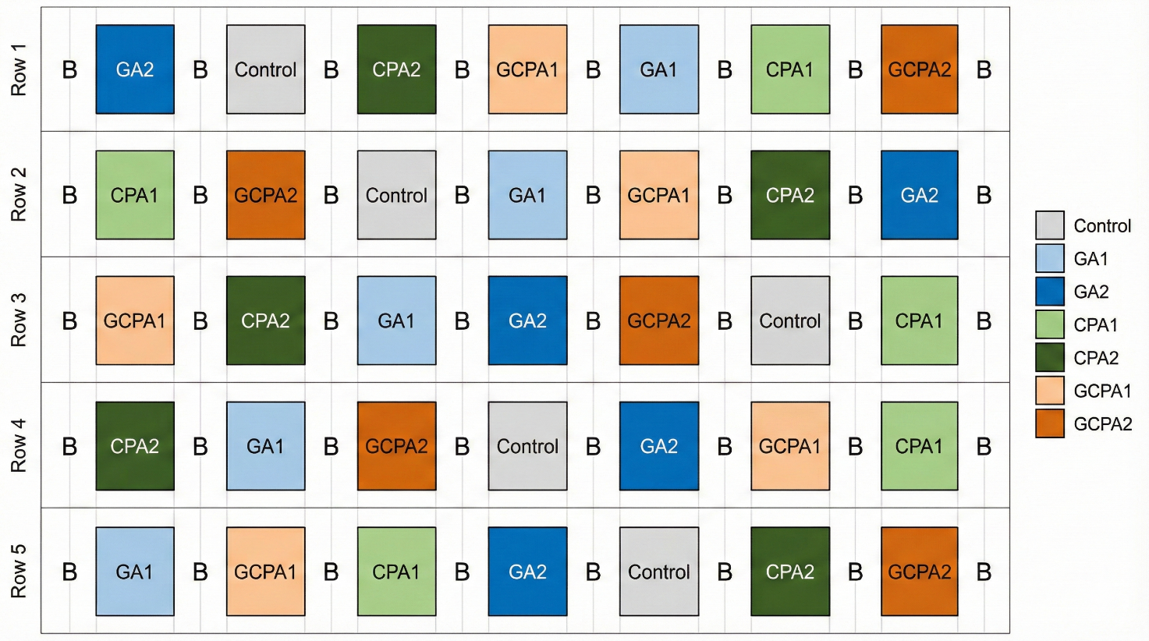
Orchard rows served as blocks. Individual trees were the experimental units, and each of the seven treatments was assigned to one tree per block, resulting in five replicate trees per treatment. Buffer trees (B) were placed between treated trees in both horizontal and vertical directions, and an additional buffer border surrounded the experimental area to prevent cross-contamination from spray drift. GA1 and GA2 indicate GA₃ at 25 and 50 ppm; CPA1 and CPA2 indicate 4-CPA at 10 and 20 ppm; and GCPA1 and GCPA2 indicate combined GA₃ + 4-CPA at 20 + 10 and 40 + 20 ppm, respectively.

