Supplementary Table S5. Comparison of genes selected for DEGs set II.

Supplementary 5.1. Number of selected genes for differentially expressed genes set Ⅱ.
Treatment vs Control ^{z} | Regulation pattern | Num. of DEGs | Annotated DEGs
J7 vs B7 | Up | 148 | 147
J7 vs B7 | Down | 14 | 13
J8 vs B8 | Up | 42 | 39
J8 vs B8 | Down | 378 | 359
J9 vs B9 | Up | 536 | 513
J9 vs B9 | Down | 105 | 101
J10 vs B10 | Up | 89 | 78
J10 vs B10 | Down | 198 | 185
^{z}B7: ‘Fuyu’ at 9 weeks after full bloom (WAB); B8: ‘Fuyu’ at 12 WAB; B9: ‘Fuyu’ at 15 WAB; B10: ‘Fuyu’ at 18 WAB; J7: ‘Soshu’ at 9 WAB; J8: ‘Soshu’ at 12 WAB; J9: ‘Soshu’ at 15 WAB; J10: ‘Soshu’ at 18 WAB.

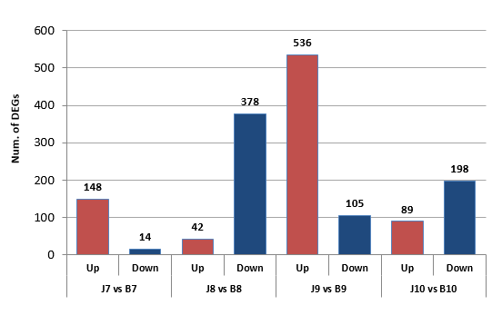
B7: ‘Fuyu’ at 9 weeks after full bloom (WAB); B8: ‘Fuyu’ at 12 WAB; B9: ‘Fuyu’ at 15 WAB; B10: ‘Fuyu’ at 18 WAB; J7: ‘Soshu’ at 9 WAB; J8: ‘Soshu’ at 12 WAB; J9: ‘Soshu’ at 15 WAB; J10: ‘Soshu’ at 18 WAB.
Supplementary 5.2. Number of genes for differentially expressed genes set Ⅱ.
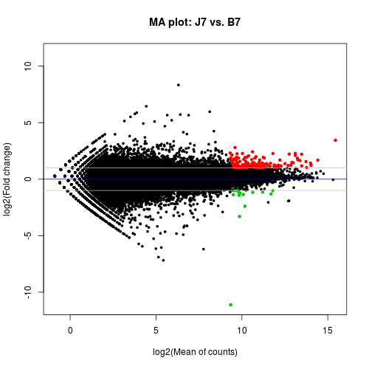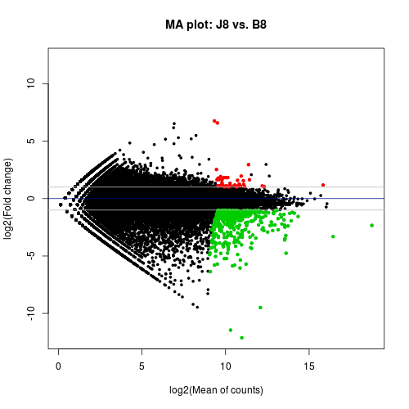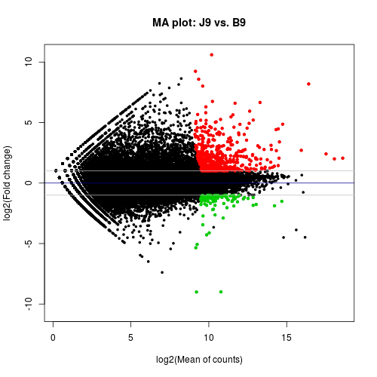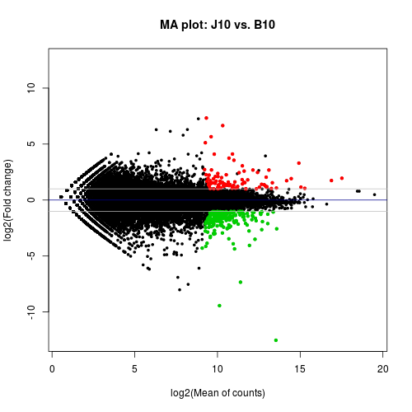
B7: ‘Fuyu’ at 9 weeks after full bloom (WAB); B8: ‘Fuyu’ at 12 WAB; B9: ‘Fuyu’ at 15 WAB; B10: ‘Fuyu’ at 18 WAB; J7: ‘Soshu’ at 9 WAB; J8: ‘Soshu’ at 12 WAB; J9: ‘Soshu’ at 15 WAB; J10: ‘Soshu’ at 18 WAB.
Supplementary 5.3. MA plot for differentially expressed genes set II

