Supplementary Table S4. Comparison of genes selected for DEGs set I.

Supplementary 4.1. Number of selected genes for DEGs set I.
Treatment vs Control ^{z} | Regulation pattern | Num. of DEGs | Annotated DEGs
B8 vs B7 | Up | 1,096 | 1,059
B8 vs B7 | Down | 161 | 152
B9 vs B7 | Up | 705 | 686
B9 vs B7 | Down | 82 | 79
B10 vs B7 | Up | 1,886 | 1,722
B10 vs B7 | Down | 177 | 169
J8 vs J7 | Up | 404 | 385
J8 vs J7 | Down | 143 | 141
J9 vs J7 | Up | 1,435 | 1,310
J9 vs J7 | Down | 272 | 268
J10 vs J7 | Up | 1,134 | 1,099
J10 vs J7 | Down | 329 | 324
^{z}B7: ‘Fuyu’ at 9 weeks after full bloom (WAB); B8: ‘Fuyu’ at 12 WAB; B9: ‘Fuyu’ at 15 WAB; B10: ‘Fuyu’ at 18 WAB; J7: ‘Soshu’ at 9 WAB; J8: ‘Soshu’ at 12 WAB; J9: ‘Soshu’ at 15 WAB; J10: ‘Soshu’ at 18 WAB.
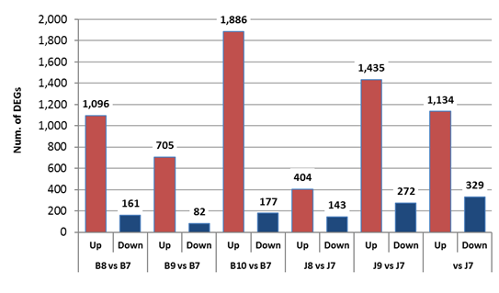
J10

B7: ‘Fuyu’ at 9 weeks after full bloom (WAB); B8: ‘Fuyu’ at 12 WAB; B9: ‘Fuyu’ at 15 WAB; B10: ‘Fuyu’ at 18 WAB; J7: ‘Soshu’ at 9 WAB; J8: ‘Soshu’ at 12 WAB; J9: ‘Soshu’ at 15 WAB; J10: ‘Soshu’ at 18 WAB.
Supplementary 4.2. Number of genes in differentially expressed genes setⅠ.

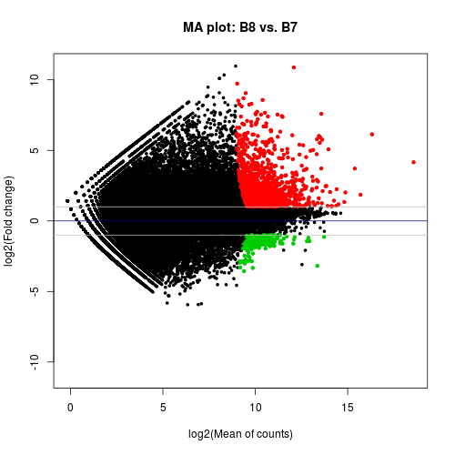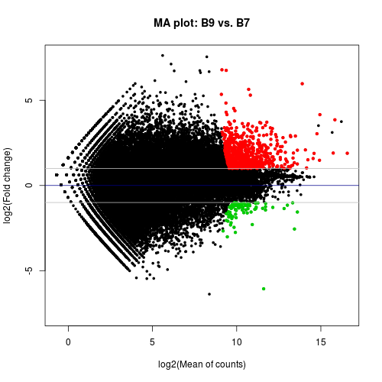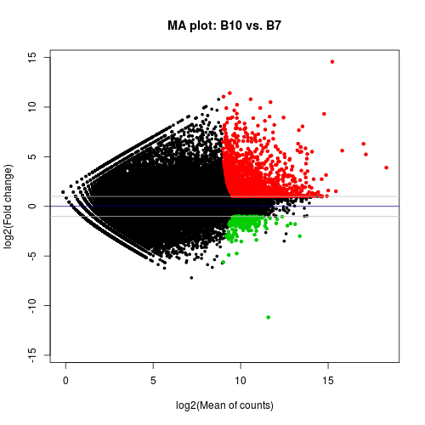
B7: ‘Fuyu’ at 9 weeks after full bloom (WAB); B8: ‘Fuyu’ at 12 WAB; B9: ‘Fuyu’ at 15 WAB; B10: ‘Fuyu’ at 18 WAB.
Supplementary 4.3. MA plot of differentially expressed genes setⅠfor ‘Fuyu’.

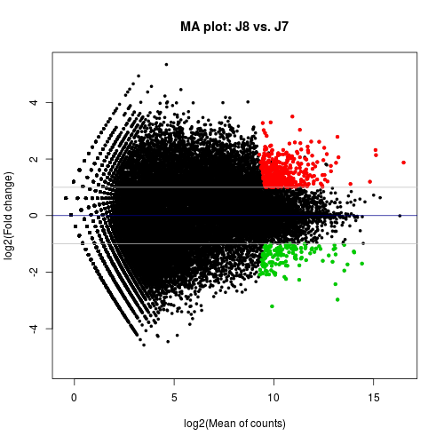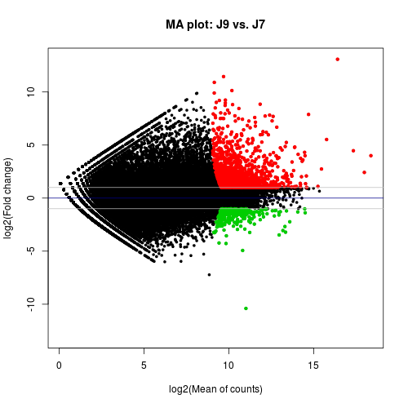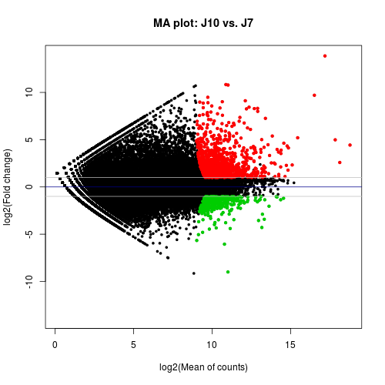
J7: ‘Soshu’ at 9 weeks after full bloom (WAB); J8: ‘Soshu’ at 12 WAB; J9: ‘Soshu’ at 15 WAB; J10: ‘Soshu’ at 18 WAB.
Supplementary 4.4. MA plot of differentially expressed genes setⅠfor ‘Soshu’.

