Supplementary Table S3. Functional annotation of transcriptome.
Supplementary 3.1. GOBP summary of representative transcripts.
GO ID | GO term | Gene count
GO:0000003 | Reproduction | 535
GO:0008152 | Metabolic process | 9,595
GO:0023052 | Signalling | 1,853
GO:0032502 | Developmental process | 3,240
GO:0040007 | Growth | 758
GO:0048511 | Rhythmic process | 150
GO:0051179 | Localization | 3,173

Supplementary 3.2. GOCC summary of representative transcripts.
GO ID | GO term | Gene count
GO:0005576 | Extracellular region | 381
GO:0005623 | Cell | 14,653
GO:0009295 | Nucleoid | 30
GO:0016020 | Membrane | 4,684
GO:0019012 | Virion | 13
GO:0031012 | Extracellular matrix | 18
GO:0043226 | Organelle | 11,794

Supplementary 3.3. GOMF summary of representative transcripts.
GO ID | GO term | Gene count
GO:0003824 | Catalytic activity | 6,671
GO:0005198 | Structural molecule activity | 301
GO:0005215 | Transporter activity | 926
GO:0009055 | Electron carrier activity | 12
GO:0016209 | Antioxidant activity | 78
GO:0016530 | Metallochaperone activity | 1

Supplementary 3.4. KOG summary of representative transcripts.
Category | Description | Gene count
A | RNA processing and modification | 513
B | Chromatin structure and dynamics | 157
C | Energy production and conversion | 491
D | Cell cycle control, cell division, chromosome partitioning | 245
E | Amino acid transport and metabolism | 461
F | Nucleotide transport and metabolism | 142
G | Carbohydrate transport and metabolism | 816
H | Coenzyme transport and metabolism | 135
I | Lipid transport and metabolism | 526
J | Translation, ribosomal structure and biogenesis | 549
K | Transcription | 1,067
L | Replication, recombination and repair | 354
M | Cell wall/membrane/envelope biogenesis | 306
N | Cell motility | 13
O | Posttranslational modification, protein turnover, chaperones | 1,286
P | Inorganic ion transport and metabolism | 349
Q | Secondary metabolites biosynthesis, transport and catabolism | 397
R | General function prediction only | 4,273
S | Function unknown | 1,289
T | Signal transduction mechanisms | 2,057
U | Intracellular trafficking, secretion, and vesicular transport | 562
V | Defense mechanisms | 381
W | Extracellular structures | 57
X | Nuclear structure | 1,754
Y | Cytoskeleton | 44
Z | Unnamed protein/Neuronal membrane glycoprotein/Myelin proteolipid protein | 236
- | not classified | 1,103

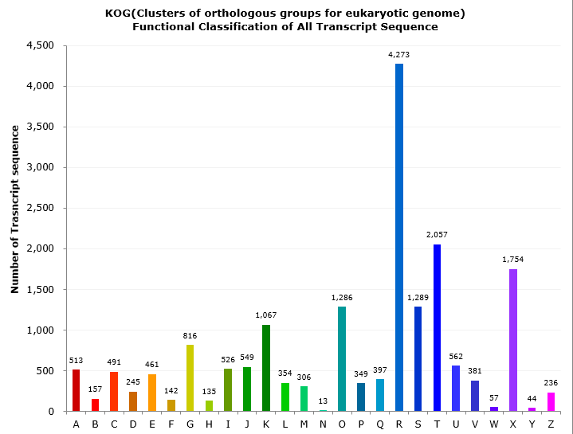
Supplementary 3.5. Histogram presentation of KOG functional classification.

Supplementary 3.6. KEGG summary of representative transcripts.
Major classification | Sub classification | TAIR count | Gene count
Cellular processes | Transport and catabolism | 144 | 348
Environmental information processing | Signal transduction | 116 | 572
Environmental information processing | Membrane transport | 18 | 64
Genetic information processing | Folding, sorting and degradation | 329 | 625
Genetic information processing | Replication and repair | 95 | 171
Genetic information processing | Transcription | 144 | 350
Genetic information processing | Translation | 441 | 717
Human diseases | Endocrine and metabolic diseases | 15 | 66
Metabolism | Overview | 1 | 1
Metabolism | Biosynthesis of other secondary metabolites | 73 | 206
Metabolism | Metabolism of terpenoids and polyketides | 104 | 223
Metabolism | Lipid metabolism | 178 | 301
Metabolism | Energy metabolism | 164 | 238
Metabolism | Metabolism of cofactors and vitamins | 129 | 205
Metabolism | Carbohydrate metabolism | 335 | 627
Metabolism | Glycan biosynthesis and metabolism | 73 | 120
Metabolism | Metabolism of other amino acids | 51 | 90
Metabolism | Amino acid metabolism | 227 | 378
Metabolism | Nucleotide metabolism | 122 | 152
Organismal systems | Environmental adaptation | 107 | 833

