Supplementary Table S1. Statistics of transcript sequencing data.

Supplementary 1.1. Statistics of transcript sequencing raw data.
Sample ID^{z} | Num. of reads | Avg. length (bp) | Total length (bp)
B7 | 18,330,729 | 101 | 1,851,403,629
B7 | 18,330,729 | 101 | 1,851,403,629
B8 | 17,201,494 | 101 | 1,737,350,894
B8 | 17,201,494 | 101 | 1,737,350,894
B9 | 22,863,852 | 101 | 2,309,249,052
B9 | 22,863,852 | 101 | 2,309,249,052
B10 | 18,470,651 | 101 | 1,865,535,751
B10 | 18,470,651 | 101 | 1,865,535,751
J7 | 19,002,793 | 101 | 1,919,282,093
J7 | 19,002,793 | 101 | 1,919,282,093
J8 | 19,401,792 | 101 | 1,959,580,992
J8 | 19,401,792 | 101 | 1,959,580,992
J9 | 16,835,744 | 101 | 1,700,410,144
J9 | 16,835,744 | 101 | 1,700,410,144
J10 | 17,221,423 | 101 | 1,739,363,723
J10 | 17,221,423 | 101 | 1,739,363,723
8ea | 298,656,956 | 101 | 30,164,352,556
^{z}B7: ‘Fuyu’ at 9 weeks after full bloom (WAB); B8: ‘Fuyu’ at 12 WAB; B9: ‘Fuyu’ at 15 WAB; B10: ‘Fuyu’ at 18 WAB; J7: ‘Soshu’ at 9 WAB; J8: ‘Soshu’ at 12 WAB; J9: ‘Soshu’ at 15 WAB; J10: ‘Soshu’ at 18 WAB.

Supplementary 1.2. Sequencing raw data after removing the PCR duplication.
Sample ID^{z} | Num. of reads | Avg. length (bp) | Total length (bp)
B7 | 16,048,260 | 101 | 1,620,874,260
B7 | 16,048,260 | 101 | 1,620,874,260
B8 | 11,714,396 | 101 | 1,183,153,996
B8 | 11,714,396 | 101 | 1,183,153,996
B9 | 17,794,045 | 101 | 1,797,198,545
B9 | 17,794,045 | 101 | 1,797,198,545
B10 | 12,544,285 | 101 | 1,266,972,785
B10 | 12,544,285 | 101 | 1,266,972,785
J7 | 15,921,519 | 101 | 1,608,073,419
J7 | 15,921,519 | 101 | 1,608,073,419
J8 | 13,147,128 | 101 | 1,327,859,928
J8 | 13,147,128 | 101 | 1,327,859,928
J9 | 11,192,866 | 101 | 1,130,479,466
J9 | 11,192,866 | 101 | 1,130,479,466
J10 | 11,442,192 | 101 | 1,155,661,392
J10 | 11,442,192 | 101 | 1,155,661,392
8ea | 219,609,382 | 101 | 22,180,547,582
^{z}B7: ‘Fuyu’ at 9 weeks after full bloom (WAB); B8: ‘Fuyu’ at 12 WAB; B9: ‘Fuyu’ at 15 WAB; B10: ‘Fuyu’ at 18 WAB; J7: ‘Soshu’ at 9 WAB; J8: ‘Soshu’ at 12 WAB; J9: ‘Soshu’ at 15 WAB; J10: ‘Soshu’ at 18 WAB.

Supplementary 1.3. Distribution of transcripts based on length after final assembly.
Length (bp) |  | Total transcripts |  | Representative transcripts
200 | ~ 500 | 23,431 | 15,632
501 | ~ 1000 | 17,120 | 6,781
1001 | ~ 1500 | 16,301 | 3,994
1501 | ~ 2000 | 15,058 | 3,021
2001 | ~ 2500 | 11,031 | 1,915
2501 | ~ 3000 | 7,581 | 1,169
3001 | ~ 3500 | 4,783 | 699
3501 | ~ 4000 | 3,048 | 390
4001 | ~ 4500 | 2,053 | 249
4501 |  | 4,168 | 442
Total |  | 104,574 | 34,292

Supplementary 1.4. Statistics of reads mapping to assembled gene set.
Sample ID^{z} | Total reads | Aligned 0 times |  | Mapping rate
Sample ID^{z} | Total reads | Reads (ea) | Percent (%) | Reads (ea) | Percent (%)
B7 | 13,788,623 | 2,182,561 | 15.83 | 11,606,062 | 84.17
B7 | 13,788,623 | 2,201,828 | 15.97 | 11,586,795 | 84.03
B8 | 9,948,572 | 1,622,845 | 16.31 | 8,325,727 | 83.69
B8 | 9,948,572 | 1,586,444 | 15.95 | 8,362,128 | 84.05
B9 | 13,697,259 | 1,931,970 | 14.10 | 11,765,289 | 85.90
B9 | 13,697,259 | 2,046,275 | 14.94 | 11,650,984 | 85.06
B10 | 10,581,409 | 1,558,921 | 14.73 | 9,022,488 | 85.27
B10 | 10,581,409 | 1,531,690 | 14.48 | 9,049,719 | 85.52
J7 | 13,870,478 | 1,980,424 | 14.28 | 11,890,054 | 85.72
J7 | 13,870,478 | 2,000,296 | 14.42 | 11,870,182 | 85.58
J8 | 11,273,123 | 1,709,090 | 15.16 | 9,564,033 | 84.84
J8 | 11,273,123 | 1,715,483 | 15.22 | 9,557,640 | 84.78
J9 | 9,353,682 | 1,453,360 | 15.54 | 7,900,322 | 84.46
J9 | 9,353,682 | 1,452,878 | 15.53 | 7,900,804 | 84.47
J10 | 9,553,720 | 1,699,321 | 17.79 | 7,854,399 | 82.21
J10 | 9,553,720 | 1,694,794 | 17.74 | 7,858,926 | 82.26
8ea | 184,133,732 | 28,368,180 | 15.41 | 155,765,552 | 84.59
^{z}B7: ‘Fuyu’ at 9 weeks after full bloom (WAB); B8: ‘Fuyu’ at 12 WAB; B9: ‘Fuyu’ at 15 WAB; B10: ‘Fuyu’ at 18 WAB; J7: ‘Soshu’ at 9 WAB; J8: ‘Soshu’ at 12 WAB; J9: ‘Soshu’ at 15 WAB; J10: ‘Soshu’ at 18 WAB.
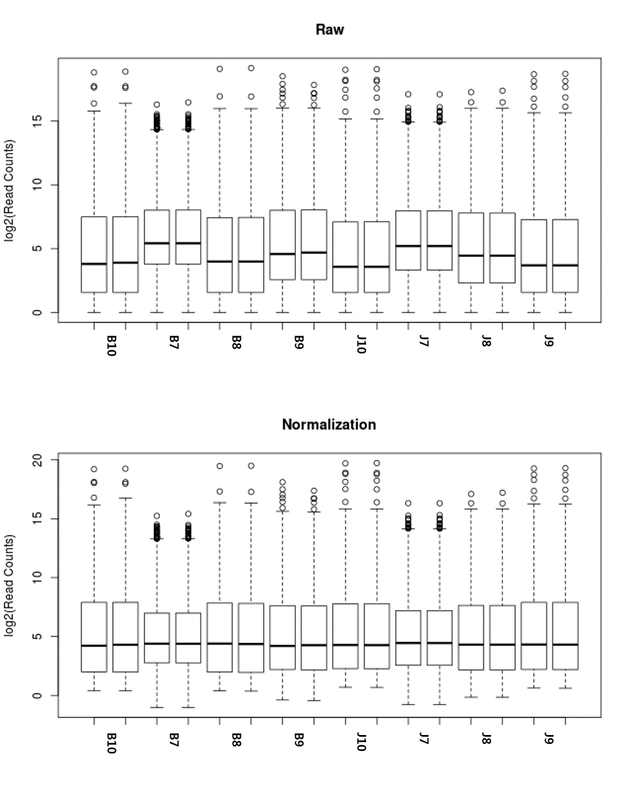
Supplementary 1.5. Boxplot of gene expression before and after normalization.
B7: ‘Fuyu’ at 9 weeks after full bloom (WAB); B8: ‘Fuyu’ at 12 WAB; B9: ‘Fuyu’ at 15 WAB; B10: ‘Fuyu’ at 18 WAB; J7: ‘Soshu’ at 9 WAB; J8: ‘Soshu’ at 12 WAB; J9: ‘Soshu’ at 15 WAB; J10: ‘Soshu’ at 18 WAB.

